Thinktank, Birmingham Science Museum Shop

Group Goodie Bag Order Form

We stock a range of items suitable to be purchased in the form of goodie bags for groups who may not have time to visit the shop on their visit (which you are welcome to do!).

Please browse the following list and choose the items and quantities you would like to purchase. If we are out of stock of a particular item we will substitute it for a suitable alternative.

Bags can be collected and paid for in the Museum Shop on the day of your visit.

Thank you for visiting Thinktank, we hope you have an enjoyable time.

If you have any queries please contact the Shop directly on 0121 348 8072, and we will be happy to help.

Please complete the order form and return to:shop@birminghammuseums.org.uk and educationbookings@birminghammuseums.org.uk

Items
Planetarium Pencil  90p | 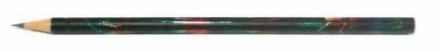
Thinktank Recycled Pencil

£1.00
Thinktank Recycled Pen

£1.50

Multiwriter Pen  £2.00 | 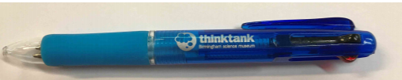
Fridge Magnet  £2.50 | 
Notepad & Pen  £2.50 | 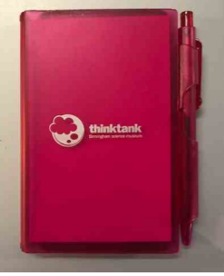
Thinktank Cloth Badge  £2.00 | 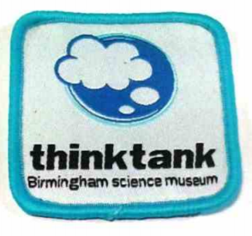
Fleur Highlighter  £2.50 | 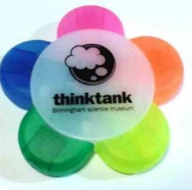
Thinktank Button Badge  £1.00 | 
Thinktank Chunky Enviro Eraser

£1.00

Plastic Spring  £2.50 | 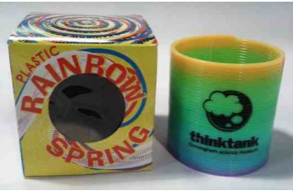
Exclusive Thinktank Top Trumps  £3.50 | 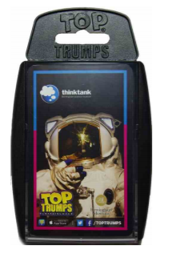
Thinktank Double Sharpener

£1.00
Bouncing Putty

£2.50
Thinktank Bubble Blower

£2.00

ORDER

Item | Price (each) | Quantity | Total
Planetarium Pencil | 90p
Thinktank Recycled Pencil | £1.00
Thinktank Recycled Pen | £1.50
Multi Writer Pen | £2.00
Thinktank Fridge Magnet | £2.50
Notepad & Pen | £2.50
Thinktank Cloth Badge | £2.00
Fleur Highlighter | £2.50
Thinktank Button Badge | £1.00
Thinktank Chunky Enviro Eraser | £1.00
Plastic Spring | £2.50
Thinktank Top Trumps | £3.50
Thinktank Double Sharpener | £1.50
Bouncing Putty | £2.50
Thinktank Bubble Blower | £2.00
 |  | Total: | £

Please complete the order form and return to shop@birminghammuseums.org.uk and educationbookings@birminghammuseums.org.uk

Name of School:
Contact Number/Email:
Date of Visit:
Payment method (please circle): Card Cash Invoice

